Automate the Alarm Clock Smart Contract on the Public Blockchain

* Create a file called Alarm.js which catches the real-time events emitted from the Smart Contract called Alarm.sol

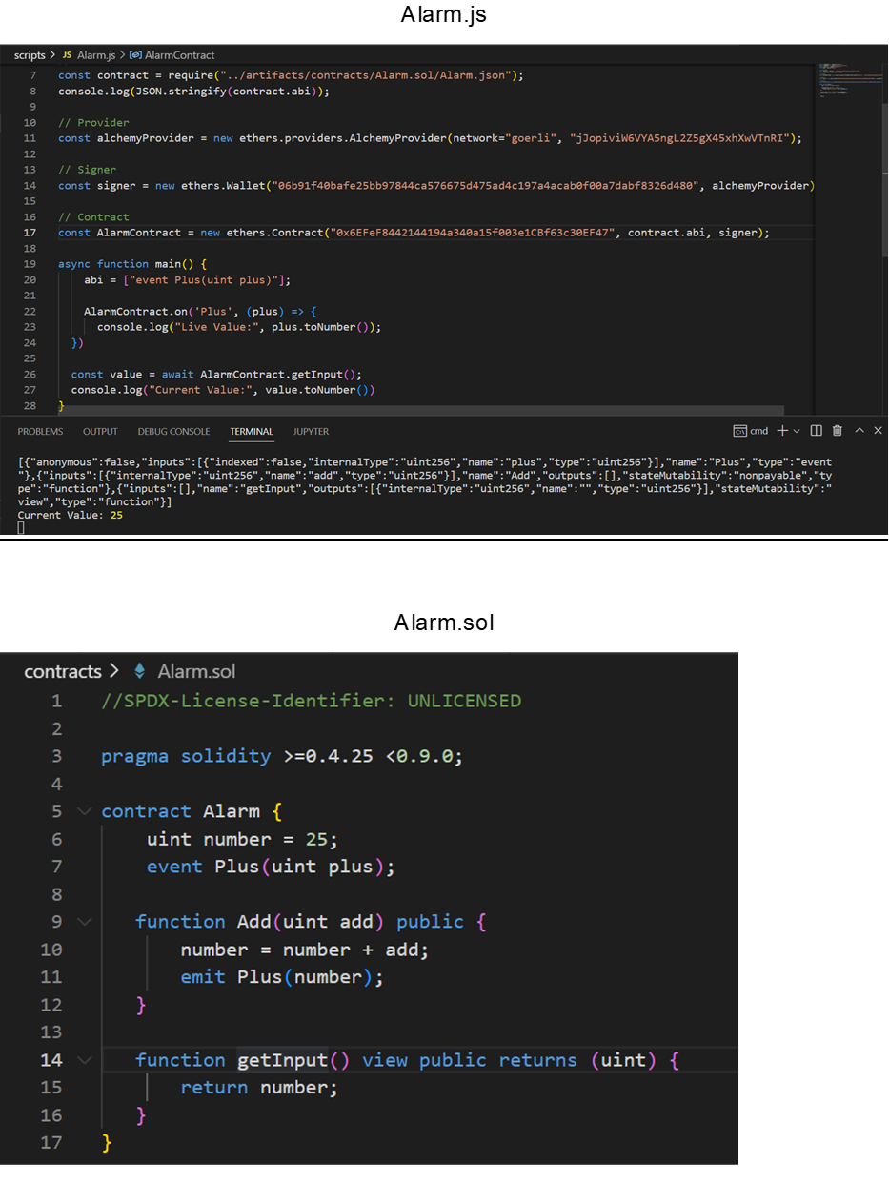

* Deploy the Smart Contract, Alarm.sol through the deploy script; deploy.js onto the public blockchain aka. goreli block explorer.

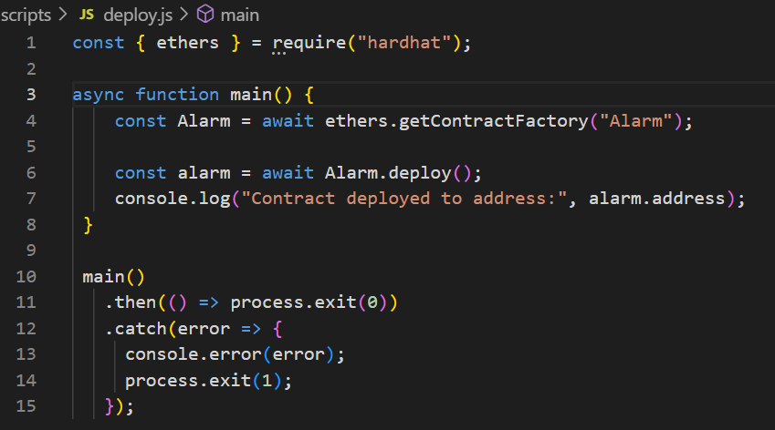



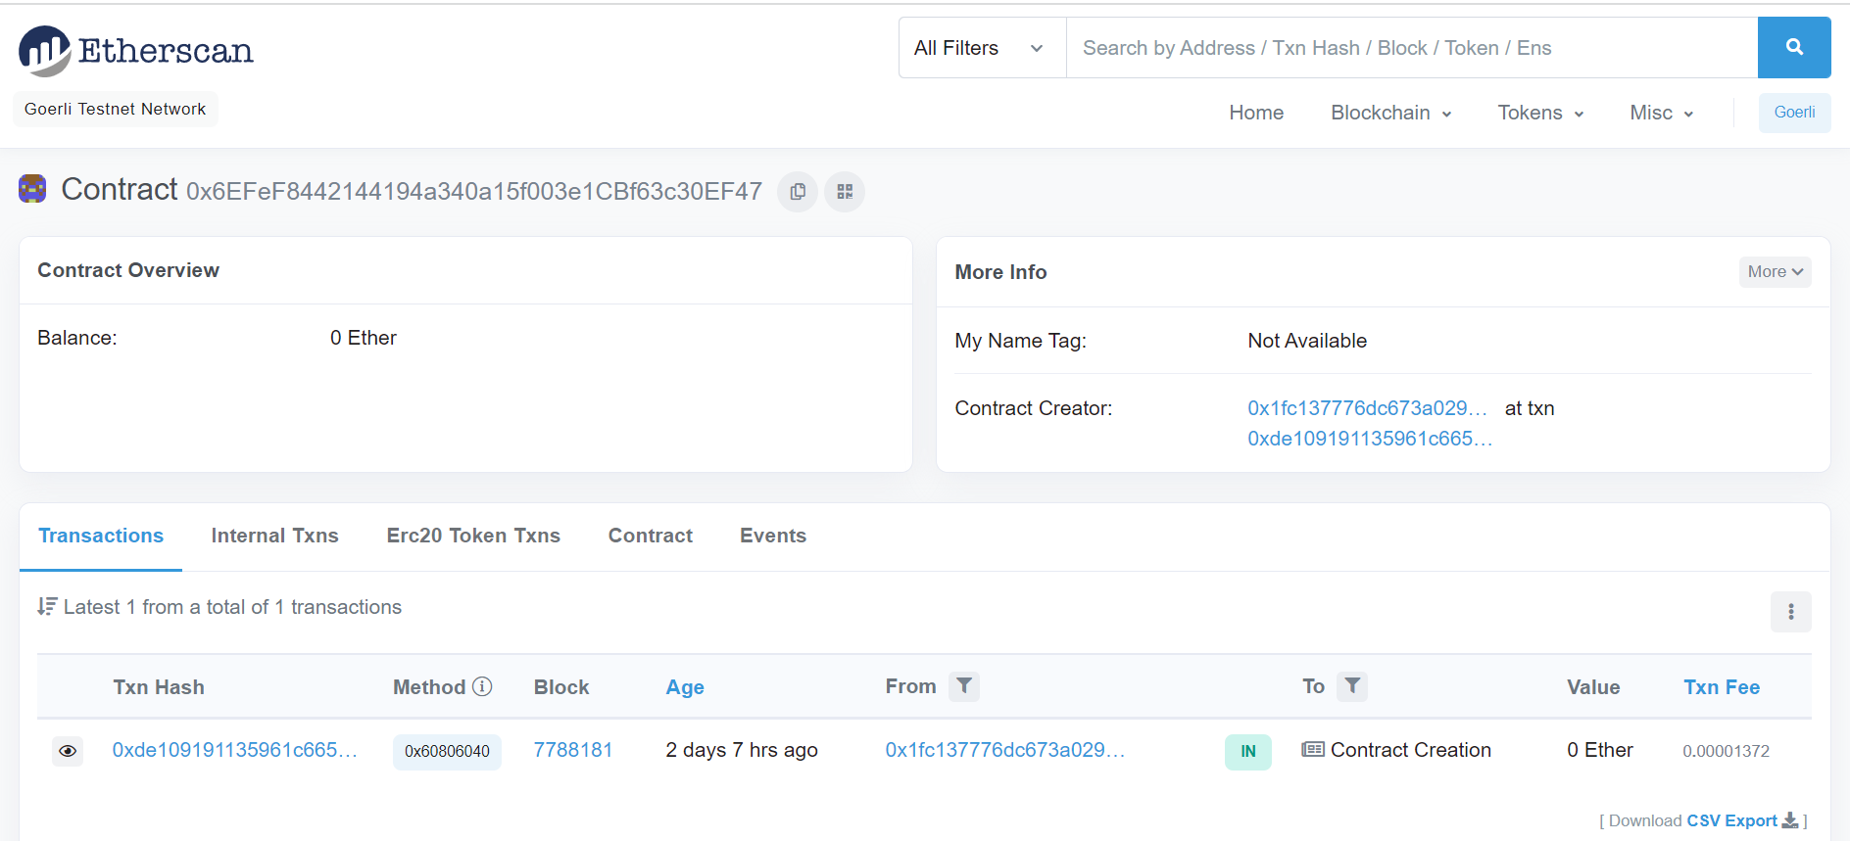

* Visit the Gelato Automation Network and input the abi of the deployed smart contract from hardhat contract artifacts

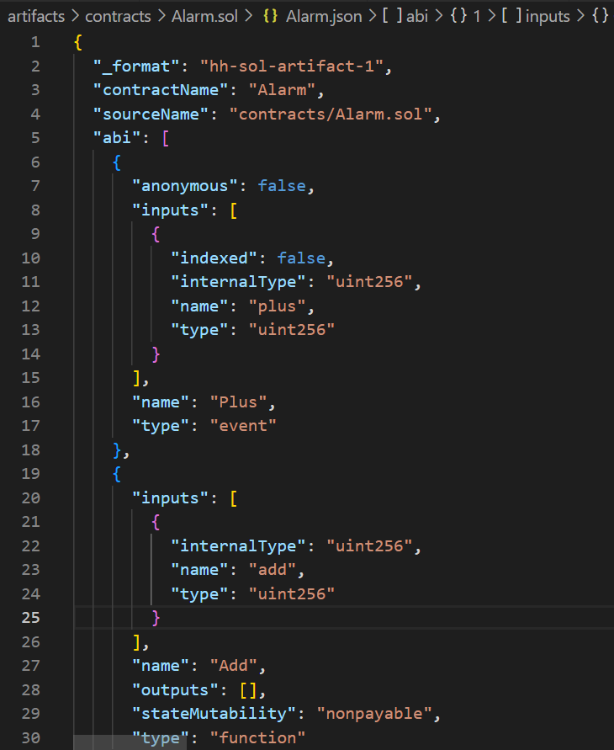

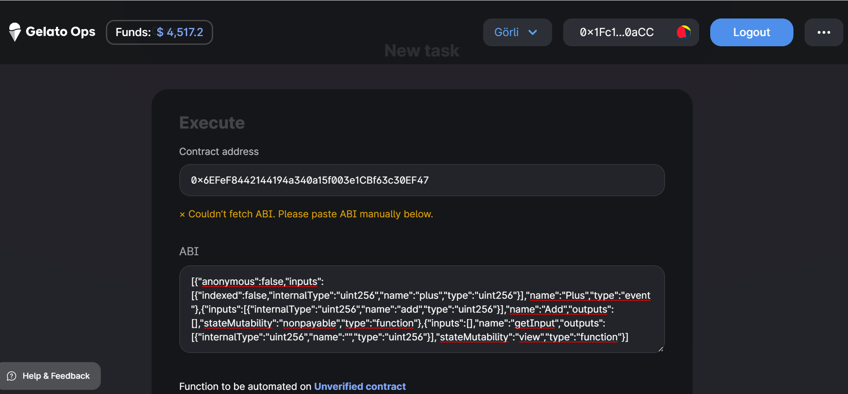

* Automate the add function in the deployed smart contract with the value of “1” every 25 seconds

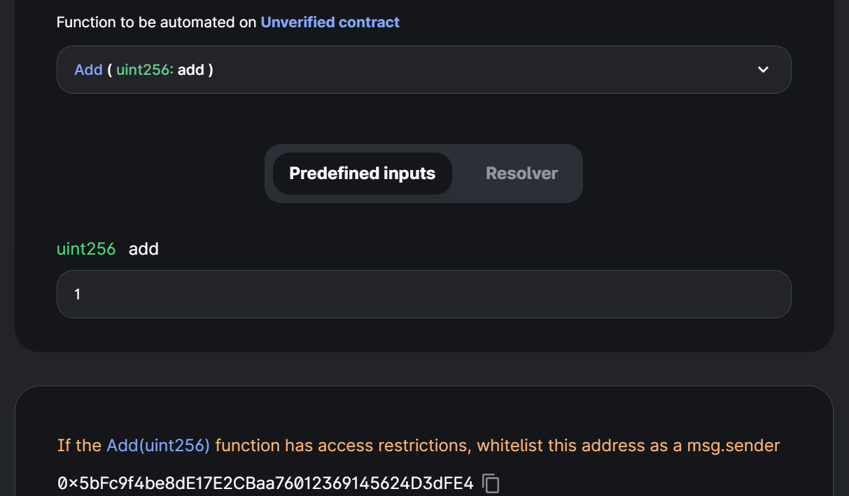

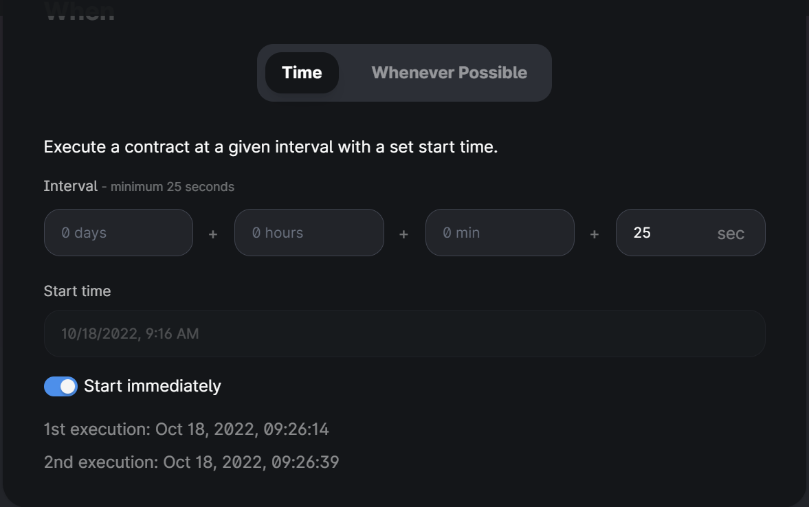

* Name the Automated Smart Contract to be called; “Alarm Event”

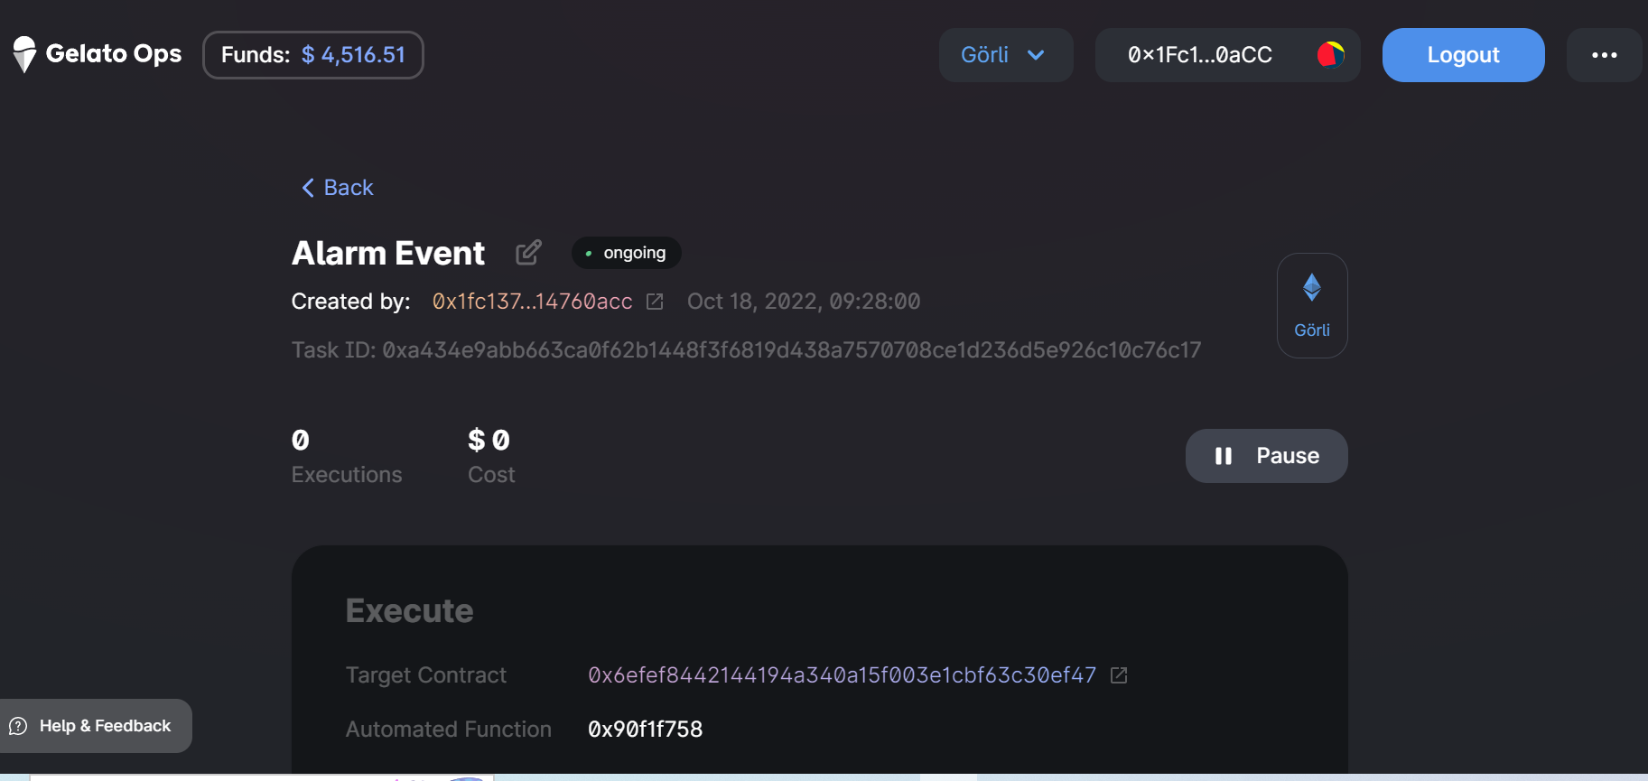

* Click on funds and deposit your goreli test faucet and then use the Gelato Balance to pay for the transaction fee whenever the smart contract is being automated

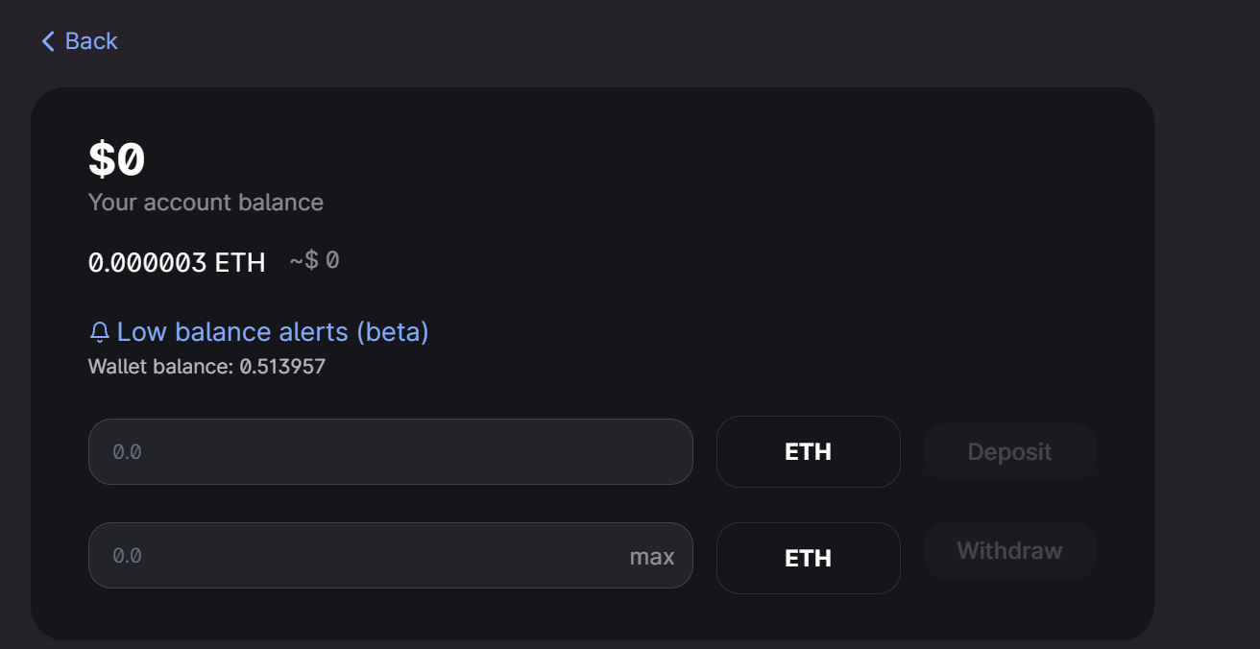

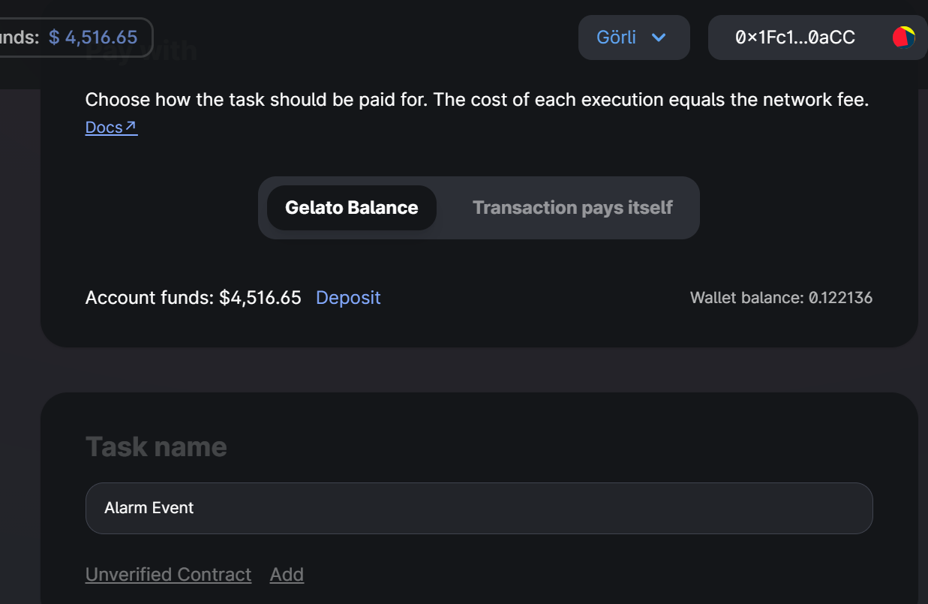

* Congrats! Your automated smart contract is now running. Run the Alarm.js file and wait for 2 executions to be executed with the gelato network. Your Alarm.js file should be able to catch the current value and the live value of each increment counter every 25 seconds

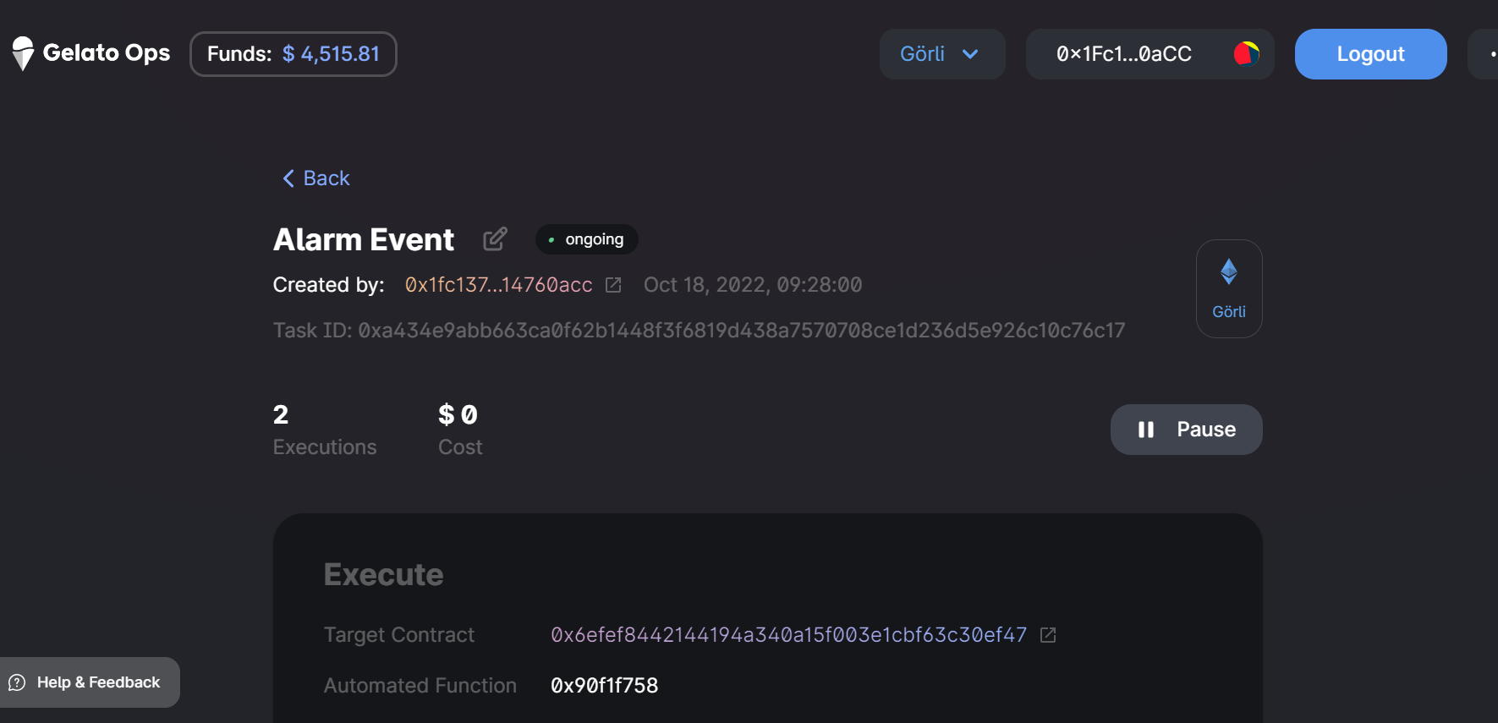

Result:

